|  |  |
| --- | --- |
| **Name: Rohil Ahuja** | **Registration no.: 20BRS1204** |
| **Lab no.: Lab1** | ***Course code: CSE2023*** |

**Q1) Printing Hello World through message box in UiPath?**

**Ans.**

**Steps to create a process Hello World:**

* **Step 1: Open UiPath studio and create a process called “Hello World”.**
* **Step 2: Create a sequence called “Hello World”.**
* **Step 3: Drag and drop a Message box in the sequence which pops up a message “Hello World”.**
* **Step 4: We can also add comments inside the sequence.**
* **Step 5: To add a custom comment, we can select the comment box and go to properties to add a comment.**
* **Step 6: A pop up message will be displayed on your screen.**

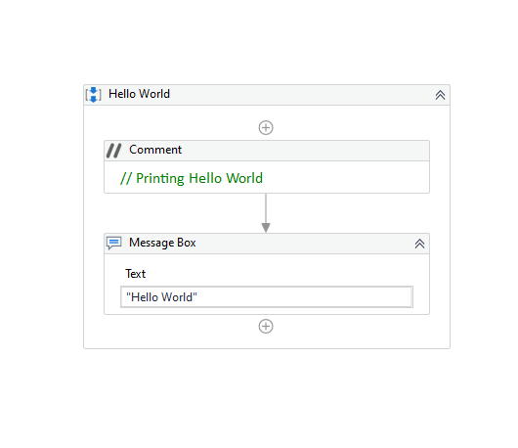

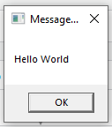

**Q2) How to Swap values of variables on UiPath?**

**Ans.**

**Steps to complete this process of swapping values of variables:**

* **Step 1: Open UiPath studio and create a process called “Swapping Values of Variables”.**
* **Step 2: Create a sequence called “Sequence for swapping values of variables”.**
* **Step 3: Drag and drop an Input dialog in your sequence to take input for the first number.**
* **Step 4: Insert the Dialog title and the Input label for that Input dialog, along with that create a variable num1 which stores the value given by the user.**
* **Step 5: Repeat the steps for the second Input dialog and let the variable be num2.**
* **Step 6: Now drag and drop a Multiple assign in your sequence to swap the values of num1 and num2.**
* **Step 7: The procedure to swap the values is:**
  + **First create a temporary variable “temp”.**
  + **Then assign temp = num1.**
  + **Now temp stores the value of num1.**
  + **Then assign the value of num2 = num1.**
  + **At last, assign the value of temp to num2.**
  + **After completing all these steps, the values are swapped.**
* **Step 8: To print the swapped values, first drag and drop Write Line.**
* **Step 9: Add “**"Final Value of Num1: " +Num1 + Environment.NewLine + "Final Value of Num2: " + Num2” **in the text block of Write line.**
* **Step 10: The output would be printed in the Output section.**



